**Pub/Sub: Qwik Start - Command Line**

experimentLabschedule40 minutesuniversal_currency_altNo costshow_chartIntroductory

Rate Lab

**GSP095**



**Overview**

Pub/Sub is a messaging service for exchanging event data among applications and services. By decoupling senders and receivers, it allows for secure and highly available communication between independently written applications. Pub/Sub delivers low-latency/durable messaging, and is commonly used by developers in implementing asynchronous workflows, distributing event notifications, and streaming data from various processes or devices.

What you'll learn

In this lab, you will do the following:

* Create, delete, and list Pub/Sub topics and subscriptions
* Publish messages to a topic
* How to use a pull subscriber

Prerequisites

This is an **introductory** level lab. This assumes little or no prior experience with Pub/Sub, and it will teach you the basics of setting up and using this Google Cloud service.

**Setup and requirements**

Before you click the Start Lab button

Read these instructions. Labs are timed and you cannot pause them. The timer, which starts when you click **Start Lab**, shows how long Google Cloud resources will be made available to you.

This hands-on lab lets you do the lab activities yourself in a real cloud environment, not in a simulation or demo environment. It does so by giving you new, temporary credentials that you use to sign in and access Google Cloud for the duration of the lab.

To complete this lab, you need:

* Access to a standard internet browser (Chrome browser recommended).

**Note:** Use an Incognito or private browser window to run this lab. This prevents any conflicts between your personal account and the Student account, which may cause extra charges incurred to your personal account.

* Time to complete the lab---remember, once you start, you cannot pause a lab.

**Note:** If you already have your own personal Google Cloud account or project, do not use it for this lab to avoid extra charges to your account.

How to start your lab and sign in to the Google Cloud console

1. Click the **Start Lab** button. If you need to pay for the lab, a pop-up opens for you to select your payment method. On the left is the **Lab Details** panel with the following:
   * The **Open Google Cloud console** button
   * Time remaining
   * The temporary credentials that you must use for this lab
   * Other information, if needed, to step through this lab
2. Click **Open Google Cloud console** (or right-click and select **Open Link in Incognito Window** if you are running the Chrome browser).

The lab spins up resources, and then opens another tab that shows the **Sign in** page.

***Tip:*** Arrange the tabs in separate windows, side-by-side.

**Note:**If you see the **Choose an account** dialog, click **Use Another Account**.

1. If necessary, copy the **Username** below and paste it into the **Sign in** dialog.

"Username"

Copied!

content_copy

You can also find the **Username** in the **Lab Details** panel.

1. Click **Next**.
2. Copy the **Password** below and paste it into the **Welcome** dialog.

"Password"

Copied!

content_copy

You can also find the **Password** in the **Lab Details** panel.

1. Click **Next**.

**Important:**You must use the credentials the lab provides you. Do not use your Google Cloud account credentials.**Note:**Using your own Google Cloud account for this lab may incur extra charges.

1. Click through the subsequent pages:
   * Accept the terms and conditions.
   * Do not add recovery options or two-factor authentication (because this is a temporary account).
   * Do not sign up for free trials.

After a few moments, the Google Cloud console opens in this tab.

**Note:** To view a menu with a list of Google Cloud products and services, click the **Navigation menu** at the top-left. 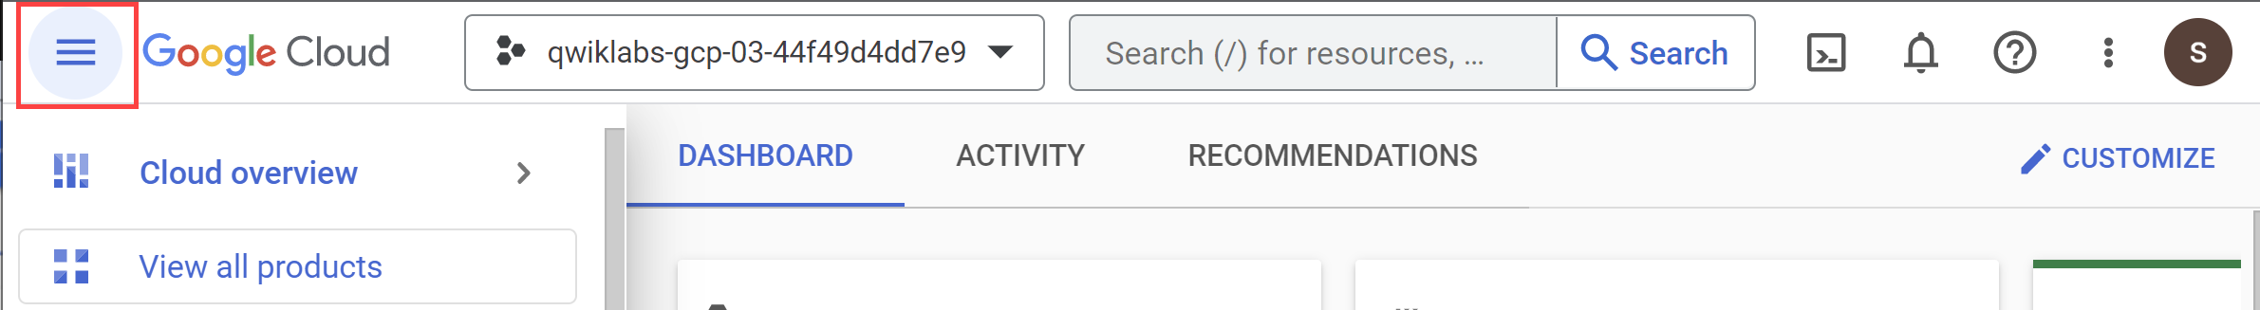

Activate Cloud Shell

Cloud Shell is a virtual machine that is loaded with development tools. It offers a persistent 5GB home directory and runs on the Google Cloud. Cloud Shell provides command-line access to your Google Cloud resources.

1. Click **Activate Cloud Shell** Activate Cloud Shell icon at the top of the Google Cloud console.

When you are connected, you are already authenticated, and the project is set to your **Project_ID**, PROJECT_ID. The output contains a line that declares the **Project_ID** for this session:

Your Cloud Platform project in this session is set to "PROJECT_ID"

gcloud is the command-line tool for Google Cloud. It comes pre-installed on Cloud Shell and supports tab-completion.

1. (Optional) You can list the active account name with this command:

gcloud auth list

Copied!

content_copy

1. Click **Authorize**.

**Output:**

ACTIVE: *

ACCOUNT: "ACCOUNT"

To set the active account, run:

$ gcloud config set account `ACCOUNT`

1. (Optional) You can list the project ID with this command:

gcloud config list project

Copied!

content_copy

**Output:**

[core]

project = "PROJECT_ID"

**Note:**For full documentation of gcloud, in Google Cloud, refer to [the gcloud CLI overview guide](https://cloud.google.com/sdk/gcloud).

**Pub/Sub basics**

As stated earlier, Pub/Sub is an asynchronous global messaging service. There are three terms in Pub/Sub that appear often: topics, publishing, and subscribing.

* A topic is a shared string that allows applications to connect with one another through a common thread.
* Publishers push (or publish) a message to a Cloud Pub/Sub topic.
* Subscribers make a "subscription" to a topic where they will either pull messages from the subscription or configure webhooks for push subscriptions. Every subscriber must acknowledge each message within a configurable window of time.

To sum it up, a producer publishes messages to a topic and a consumer creates a subscription to a topic to receive messages from it.

**Task 1. Pub/Sub topics**

Pub/Sub comes preinstalled in Cloud Shell, so there are no installations or configurations required to get started with this service.

1. Run the following command to create a topic called myTopic:

gcloud pubsub topics create myTopic

Copied!

content_copy

**Test completed task**

Click **Check my progress** to verify your performed task. If you have completed the task successfully you will be granted an assessment score.

Create a Pub/Sub topic.

Check my progress

1. For good measure, create two more topics; one called Test1 and the other called Test2:

gcloud pubsub topics create Test1

Copied!

content_copy

gcloud pubsub topics create Test2

Copied!

content_copy

1. To see the three topics you just created, run the following command:

gcloud pubsub topics list

Copied!

content_copy

Your output should resemble the following:

name: projects/qwiklabs-gcp-3450558d2b043890/topics/myTopic

---

name: projects/qwiklabs-gcp-3450558d2b043890/topics/Test2

---

name: projects/qwiklabs-gcp-3450558d2b043890/topics/Test1

1. Time to clean up. Delete Test1 and Test2 by running the following commands:

gcloud pubsub topics delete Test1

Copied!

content_copy

gcloud pubsub topics delete Test2

Copied!

content_copy

1. Run the gcloud pubsub topics list command one more time to verify the topics were deleted:

gcloud pubsub topics list

Copied!

content_copy

You should get the following output:

---

name: projects/qwiklabs-gcp-3450558d2b043890/topics/myTopic

**Task 2. Pub/Sub subscriptions**

Now that you're comfortable creating, viewing, and deleting topics, time to work with subscriptions.

1. Run the following command to create a subscription called mySubscription to topic myTopic:

gcloud pubsub subscriptions create --topic myTopic mySubscription

Copied!

content_copy

**Test completed task**

Click **Check my progress** to verify your performed task. If you have completed the task successfully you will be granted an assessment score.

Create Pub/Sub Subscription.

Check my progress

1. Add another two subscriptions to myTopic. Run the following commands to make Test1 and Test2 subscriptions:

gcloud pubsub subscriptions create --topic myTopic Test1

Copied!

content_copy

gcloud pubsub subscriptions create --topic myTopic Test2

Copied!

content_copy

1. Run the following command to list the subscriptions to myTopic:

gcloud pubsub topics list-subscriptions myTopic

Copied!

content_copy

Your output should resemble the following:

---

projects/qwiklabs-gcp-3450558d2b043890/subscriptions/Test2

---

projects/qwiklabs-gcp-3450558d2b043890/subscriptions/Test1

---

projects/qwiklabs-gcp-3450558d2b043890/subscriptions/mySubscription

**Test your understanding**

Below are multiple choice questions to reinforce your understanding of this lab's concepts. Answer them to the best of your abilities.

To receive messages published to a topic, you must create a subscription to that topic.



True



False

1. Now delete the Test1 and Test2 subscriptions. Run the following commands:

gcloud pubsub subscriptions delete Test1

Copied!

content_copy

gcloud pubsub subscriptions delete Test2

Copied!

content_copy

1. See if the Test1 and Test2 subscriptions were deleted. Run the list-subscriptions command one more time:

gcloud pubsub topics list-subscriptions myTopic

Copied!

content_copy

You should get the following output:

---

projects/qwiklabs-gcp-3450558d2b043890/subscriptions/mySubscription

**Task 3. Pub/Sub publishing and pulling a single message**

Next you'll learn how to publish a message to a Pub/Sub topic.

1. Run the following command to publish the message "hello" to the topic you created previously (myTopic):

gcloud pubsub topics publish myTopic --message "Hello"

Copied!

content_copy

1. Publish a few more messages to myTopic. Run the following commands (replacing <YOUR NAME> with your name and <FOOD> with a food you like to eat):

gcloud pubsub topics publish myTopic --message "Publisher's name is <YOUR NAME>"

Copied!

content_copy

gcloud pubsub topics publish myTopic --message "Publisher likes to eat <FOOD>"

Copied!

content_copy

gcloud pubsub topics publish myTopic --message "Publisher thinks Pub/Sub is awesome"

Copied!

content_copy

Next, use the pull command to get the messages from your topic. The pull command is subscription based, meaning it should work because earlier you set up the subscription mySubscription to the topic myTopic.

1. Use the following command to pull the messages you just published from the Pub/Sub topic:

gcloud pubsub subscriptions pull mySubscription --auto-ack

Copied!

content_copy

Your output should resemble the following:

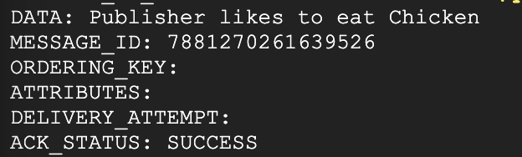

What's going on here? You published 4 messages to your topic, but only 1 was outputted.

Now is an important time to mention a couple features of the pull command that often trip developers up:

* **Using the pull command without any flags will output only one message, even if you are subscribed to a topic that has more held in it.**
* **Once an individual message has been outputted from a particular subscription-based pull command, you cannot access that message again with the pull command.**

1. To see what the second bullet is talking about, run the last command three more times. You will see that it will output the other messages you published before.
2. Now, run the command a 4th time. You'll get the following output (since there were none left to return):

gcpstaging20394_student@cloudshell:~ (qwiklabs-gcp-3450558d2b043890)$ gcloud pubsub subscriptions pull mySubscription --auto-ack

Listed 0 items.

In the last section, you will learn how to pull multiple messages from a topic with a flag.

**Task 4. Pub/Sub pulling all messages from subscriptions**

Since you pulled all of the messages from your topic in the last example, populate myTopic with a few more messages.

1. Run the following commands:

gcloud pubsub topics publish myTopic --message "Publisher is starting to get the hang of Pub/Sub"

Copied!

content_copy

gcloud pubsub topics publish myTopic --message "Publisher wonders if all messages will be pulled"

Copied!

content_copy

gcloud pubsub topics publish myTopic --message "Publisher will have to test to find out"

Copied!

content_copy

1. Add a flag to your command so you can output all three messages in one request.

You may have not noticed, but you have actually been using a flag this entire time: the --auto-ack part of the pull command is a flag that has been formatting your messages into the neat boxes that you see your pulled messages in.

limit is another flag that sets an upper limit on the number of messages to pull.

1. Wait a minute to let the topics get created. Run the pull command with the limit flag:

gcloud pubsub subscriptions pull mySubscription --auto-ack --limit=3

Copied!

content_copy

Your output should match the following:

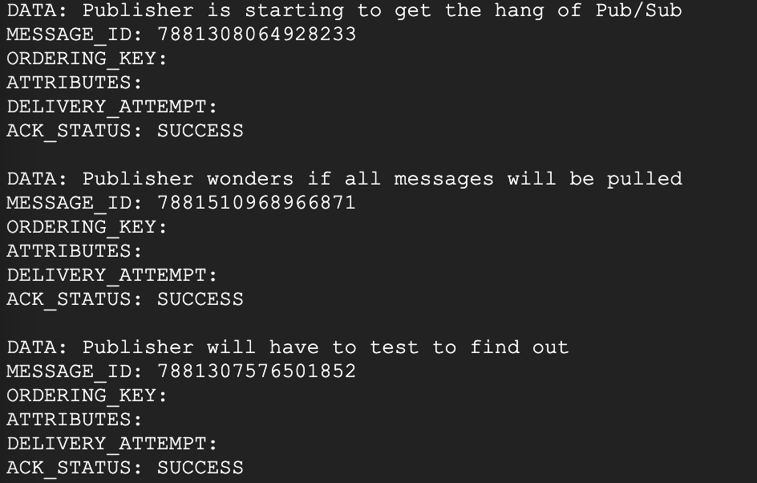

Now you know how to add flags to a Pub/Sub command to output a larger pool of messages. You are well on your way to becoming a Pub/Sub master.

**Congratulations!**

In this lab, you learned the basics of Pub/Sub topics, subscriptions, the pull command, and flags.

Take your next lab

This lab is part of a series of labs called Qwik Starts. These labs are designed to give you a little taste of the many features available with Google Cloud. Search for "Qwik Starts" in the [lab catalog](https://google.qwiklabs.com/catalog) to find the next lab you'd like to take!

Google Cloud training and certification

...helps you make the most of Google Cloud technologies. [Our classes](https://cloud.google.com/training/courses) include technical skills and best practices to help you get up to speed quickly and continue your learning journey. We offer fundamental to advanced level training, with on-demand, live, and virtual options to suit your busy schedule. [Certifications](https://cloud.google.com/certification/) help you validate and prove your skill and expertise in Google Cloud technologies.

**Manual Last Updated February 13, 2024**

**Lab Last Tested May 25, 2023**

Copyright 2024 Google LLC All rights reserved. Google and the Google logo are trademarks of Google LLC. All other company and product names may be trademarks of the respective companies with which they are associated.

[navigate_beforePrevious](https://www.cloudskillsboost.google/course_sessions/14297640/labs/464356)[Nextnavigate_next](https://www.cloudskillsboost.google/course_sessions/14297640/labs/464358)